# **Import Fuel Tank Type and Tank Data**

This document describes the steps needed to move fuel tank type (including calibration data) and fuel tank data from a BlueCube database instance to and ESO database instance.

## Required Files (Fuel Tank Type and Calibration Data)

In the Fuel Tank Type subject folder of the data extraction and loading package program files, there are 4 SQL scripts.

Step 0 - Fuel Tank Type One Time Only Cleanup

Step 1 - Fuel Tank Type Extract Source DB

Step 2a - Fuel Tank Type Insert Dest DB

Step 2b - Fuel Tank Type Calibration Insert Dest DB 01 through 04

Step 3 - Fuel Tank Type Create Types and Cal

Step 0 is only needed if there is existing fuel tank type data that needs to be reset or removed before proceeding with the import of data. In most cases it should not be used.

## Required Files (Fuel Tanks Data)

In the Fuel Tanks subject folder of the data extraction and loading package program files, there are 4 SQL scripts.

Step 0 - Fuel Tanks One Time Only Cleanup

Step 1 - Fuel Tanks Extract Source DB

Step 2 - Fuel Tank Insert Dest DB

Step 3 - Fuel Tanks Create Tanks

Step 0 is only needed if there is existing fuel tank and fuel physical tank data that needs to be reset or removed before proceeding with the import of data. In most cases it should not be used.

## Extract Source DB (Fuel Tank Type and Calibration Data from BC)

Open an instance of SQL Server Management Studio and then open a new query window. Set the database to the main BC database.

Open and Execute the query “Step 1 - Fuel Tank Type Extract Source DB”. This query will create multiple tables as follows:

1. If the data extracted from the Fuel_Tank_Type_Calibration table is less than 100,000 records the Step 1 script will create the following tables:

* bcssa_custom_integration.dbo.bc_extract_fuel_tank_type
* bcssa_custom_integration.dbo.bc_extract_fuel_tank_type_cal

1. If the data extracted from the Fuel_Tank_Type_Calibration table is more than 100,000 records the Step 1 script will create the following tables:

* bcssa_custom_integration.dbo.bc_extract_fuel_tank_type
* bcssa_custom_integration.dbo.bc_extract_fuel_tank_type_cal_01
* bcssa_custom_integration.dbo.bc_extract_fuel_tank_type_cal_02
* bcssa_custom_integration.dbo.bc_extract_fuel_tank_type_cal_03
* bcssa_custom_integration.dbo.bc_extract_fuel_tank_type_cal_04

Since the data in the “Fuel_Tank_Type_Calibration” table had more than 500,000 records, the initial extract will split the data evenly into 4 extract tables (scenario 2 above) for the calibration data. For future incremental extracts, the data should be less than 100,000 records and thus, only one extract table for the calibration data would be created.

Once the Step 1 script has been executed and completed, set the database to the database where the extract tables have been created which should be bcssa_custom_integration. Right Click on the database name and navigate to Tasks ---> Generate Scripts.

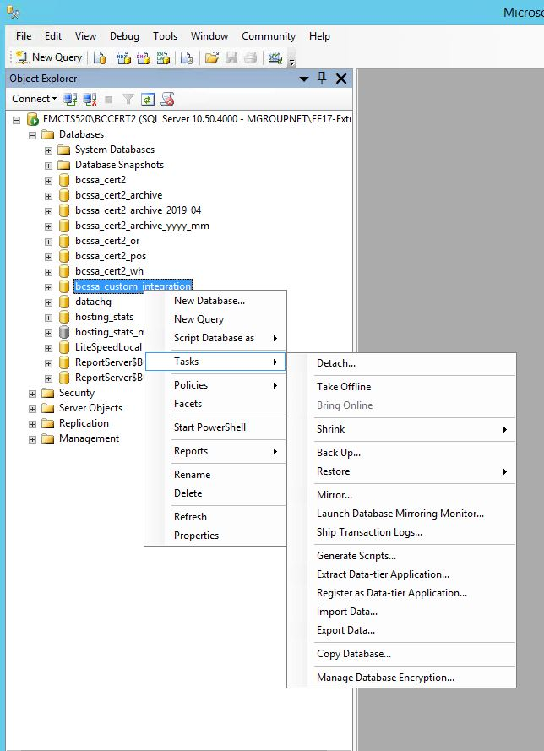

The script generation tool will be displayed.

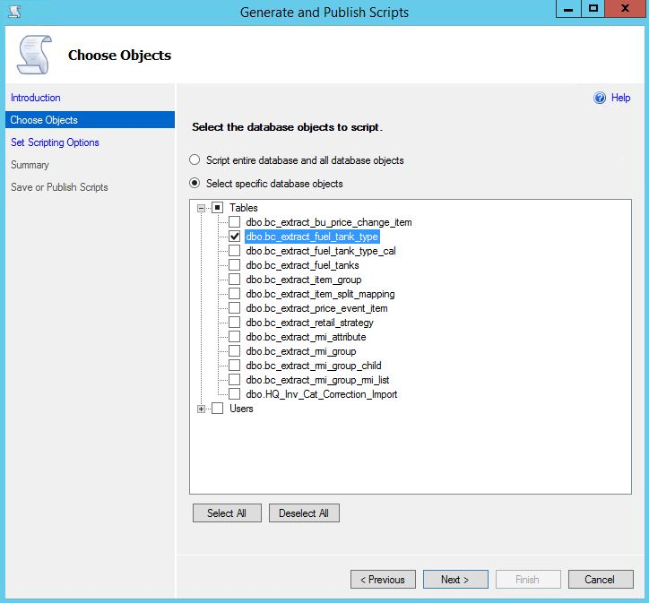

Select the option to “Select specific database objects”. Expand the list of tables and select the appropriate tables based on the scenarios above, for instance:

* bcssa_custom_integration.dbo.bc_extract_fuel_tank_type
* and bcssa_custom_integration.dbo.bc_extract_fuel_tank_type_cal (or 4 tables total)

(NOTE: Please extract each table separately, especially for the “bc_extract_fuel_tank_type_cal” tables for the initial extract.)

Click Next

The Scripting Options page will be display, Click on the Advanced button.

Set the “Types of data to script” to “Schema and data”.

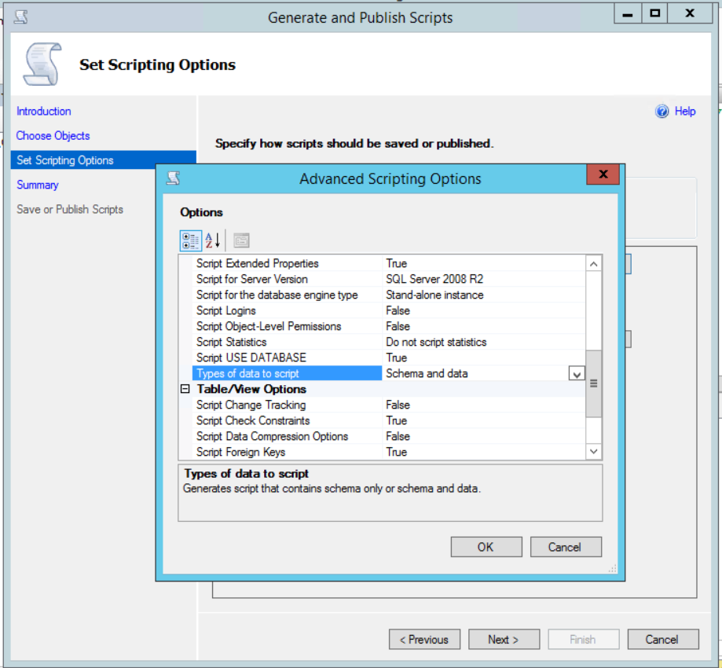

Click OK.

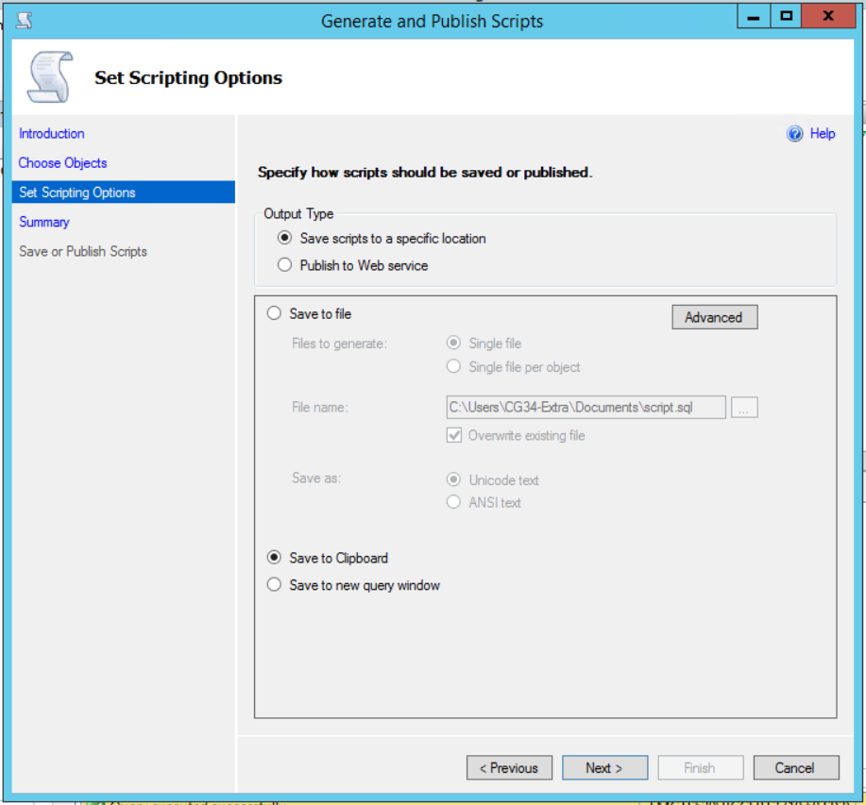

Set the option to “Save to Clipboard”. Click Next.

The Summary page will be displayed.

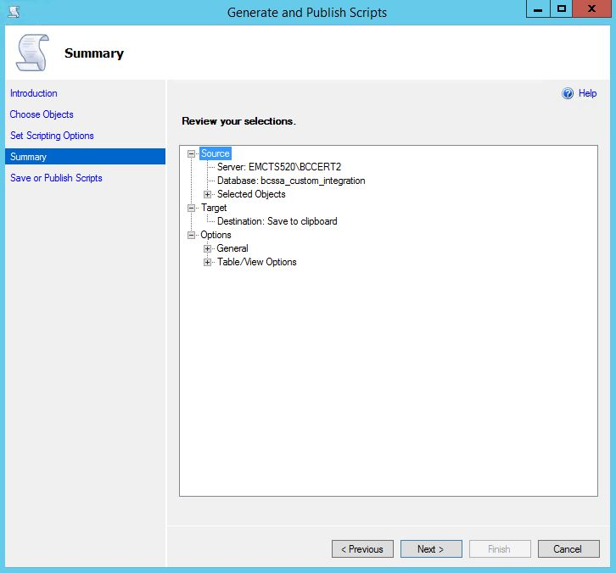

Verify the information and Click Next.

The Save or Publish Scripts page will be displayed.

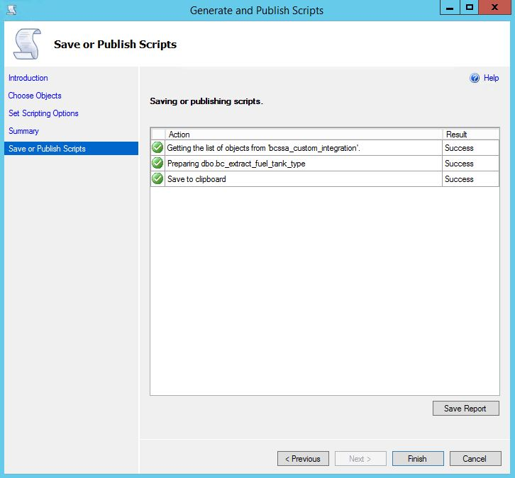

Verify the result and Click Finish. The page should disappear. The contents of the script file are now on the clipboard.

## Insert the Destination DB (Fuel Tank Type and Calibration Data into ESO)

Open an empty file in a text editor and paste the content of the clipboard into that file.

Open the script “Step 2a - Fuel Tank Type Insert Dest DB” in a text editor. Select/Highlight all INSERT statement lines and delete them from the script. Leave cursor at the position.

Go back to the file where the clipboard content had been pasted and mark/highlight all INSERT statements. Copy and paste these INSERT statements into the “Step 2a - Fuel Tank Type Insert Dest DB” file at the position where the previous INSERT statements had been located in the file. Save the file/query after the Paste operation. Discard the temporary file where the clipboard content was pasted into.

Open an instance of SQL Server Management Studio and then open a new query window. Set the database to the main ESO database.

Execute the Query “Step 2a - Fuel Tank Type Insert Dest DB”.

Follow and complete above steps to extract and insert data for every applicable file based on either scenario 1 (for 2 files total) or based on scenario 2 (for 5 files total). Please note, that in the case of 4 files for the Fuel Tank Type Calibration data (files Step 2b - Fuel Tank Type Calibration Insert Dest DB 01 through Step 2b - Fuel Tank Type Calibration Insert Dest DB 04), the following needs to be done:

* Only INSERT statements need to be replaced in each of the 4 files/scripts
* After pasting the INSERT statements into the file, PLEASE replace the table names “bc_extract_fuel_tank_type_cal_01” (or _02, _03, or _04) in the INSERT statements with “bc_extract_fuel_tank_type_cal” (as all data will be imported into one extract table in the ESO database)
* Only the first file “Step 2b - Fuel Tank Type Calibration Insert Dest DB 01” will show the create table statement; the other 3 files (_02, _03, _04) will only have INSERT statements

## Create the Fuel Tank Types and Calibrations

Open an instance of SQL Server Management Studio and then open a new query window. Set the database to the main BC/ESO database.

Execute the Query “Step 3 - Fuel Tank Type Create Types and Cal”.

Ensure that no errors are encountered and that data was inserted into the Fuel_Tank_Type and Fuel_Tank_Type_Calibration tables.

## Clean up

If needed, go to both the source and destination databases and drop the created “bc_extract_” tables that have been created as part of moving the Fuel Tank Type and Calibration data.

**NOTE: Please consider keeping the tables as it will allow for the lookup of the last max IDs prior to the next incremental extract of the data. If tables have to be deleted, please make note of the max IDs!**

## Extract Source DB (Fuel Tanks Data from BC)

Open an instance of SQL Server Management Studio and then open a new query window. Set the database to the main BC database.

Open and Execute the query “Step 1 - Fuel Tanks Extract Source DB”. This query will create the table “bcssa_custom_integration.dbo.bc_extract_fuel_tanks” containing the data for the fuel tanks.

Once the Step 1 script has been executed and completed, set the database to the database where the extract tables have been created which should be bcssa_custom_integration. Right Click on the database name and navigate to Tasks ---> Generate Scripts. Please repeat the similar steps as described for the Fuel Tank Type data to retrieve the actual data to the clipboard.

## Insert the Destination DB (Fuel Tanks Data into ESO)

Open an empty file in a text editor and paste the content of the clipboard into that file.

Open the script “Step 2 - Fuel Tank Insert Dest DB” in a text editor. Select/Highlight all INSERT statement lines and delete them from the script. Leave cursor at the position.

Go back to the file where the clipboard content had been pasted and mark/highlight all INSERT statements. Copy and paste these INSERT statements into the “Step 2 - Fuel Tank Insert Dest DB” file at the position where the previous INSERT statements had been located in the file. Save the file/query after the Paste operation. Discard the temporary file where the clipboard content was pasted into.

Open an instance of SQL Server Management Studio and then open a new query window. Set the database to the main ESO database.

Execute the Query “Step 2 - Fuel Tank Insert Dest DB”.

## Create the Fuel Tanks

Open an instance of SQL Server Management Studio and then open a new query window. Set the database to the main ESO database.

Execute the Query “Step 3 - Fuel Tanks Create Tanks”.

Ensure that no errors are encountered and that data was inserted into the Fuel_Tank and Fuel_Physical_Tank tables.

## Clean up

If needed, go to both the source and destination databases and drop the created “bc_extract_” tables that have been created as part of moving the Fuel Tanks data.

**NOTE: Please consider keeping the tables as it will allow for the lookup of the last max IDs prior to the next incremental extract of the data. If tables have to be deleted, please make note of the max IDs!**